Taking on “The Figure” in Juried National Show at East End Arts
September 17, 2015 by James Croak Art Reviews, HAMPTONS, Hamptons & East End, Reviews

It’s like tuning into a radio station while driving across a strange state. Lots of twisting and pauses, listening for something resembling the culture from whence one departed. There are stations with worried crop reports, broadcasts of vapid Muzak, high pitched gospel evangelists, talk shows with octogenarians reminiscing about the Lennon sisters, municipal proceedings over a sewage plant, a mélange of audio graffiti that one is only vaguely aware even exists.
And then the dial finally lands on one that feels familiar, one to accompany the next 50 miles. Such is the experience of viewing the juried art exhibition that attracted 714 entries, 55 of which were judged worthy of wall space at the East End Arts “4th Annual National Show (2015)” in Riverhead, NY.
This year’s theme is “The Figure.” The entries were juried by two experienced gallery owners, Kathryn Markel and Peter J. Marcelle, both of whom operate high-end galleries under their own names.
Second place went to a first-rate painting by Toby Haynes from Cornwall, England (lest anyone think portraiture is a local phenomenon). It’s a bit of a mystery piece, clever, and enjoyable to view: a woman is searching for something under the bed. This is a subject that has not enjoyed much examination in the fine arts but works here just fine.
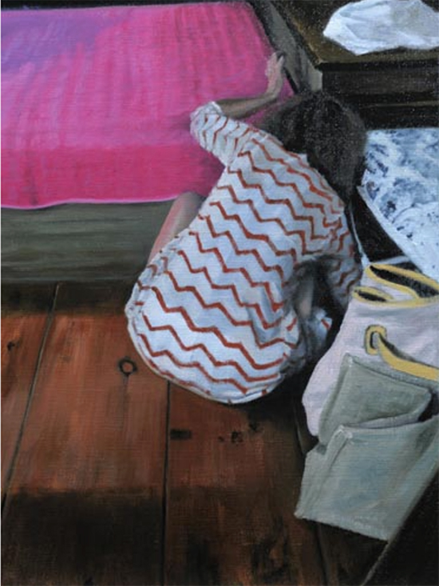

"Search Mode" by Toby Haynes.

